CsCl Gradient Phage Preparation

- Required Chemicals & Reagents
- Nutrient Broth Soft Agar (recipe per 100 mL)
  - 0.8 g Nutrient Broth
  - 0.5 g NaCl
  - 0.65 g Agar
  - 100 mL dH₂O
- Chloroform
- Phage dilution buffer
  - 10 mM Tris, pH 7.6
  - 10 mM MgCl₂
- 1.6 g/cm³ Cesium chloride
  - 1.01 g added directly to 1 mL phage dilution buffer
- 1.4 g/cm³ Cesium chloride
  - 0.61 g added directly to 1 mL phage dilution buffer
- 25% Sucrose (w/w)

- Recommended Equipment and Plasticware
- Shaking incubator
- Floor centrifuge
  - F14-14x50CY Rotor with 30 mL tube adapters
- Erlenmeyer flasks (125 mL+ depending on scale of prep)
- 30 mL Oakridge centrifuge tubes (Thermo catalog # 3119-0030)
- Ultracentrifuge
  - AH-650 Rotor with carriers
- 1 mL Syringe w/ 20 G x 1 ½ Needle
- Sorvall Thinwall tube – 5 mL (Thermo catalog # 03127)
- Dialysis Tubing
- Closures, 50 mm (Spectrum Labs catalog # 142150)

Day one

- Dip a toothpick into the desired liquid phage stock and stab an LB/agar plate.

- To 3 mL of soft agar overlay kept at 42 °C, add 3 drops of the required plating bacteria.

- Pour the soft agar over the plate and swirl.

- Allow the soft agar to solidify and incubate overnight at the desired temperature.

Day two

- Add 30 mL LB to a 125 mL Erlenmeyer flask.

- Inoculate the flask with 300 μL of cells from an overnight culture (the volume may vary based on cell type).

- Pick a plaque from the plate made on day one and add it to the flask with cells.

- Incubate at 37 °C while shaking at 200 RPM for 6 hours or until clear.

- Add ~3 mL of chloroform and continue to incubate for 5 minutes.

- Remove the flask from the incubator and carefully pour the supernatant into a 30 mL Oakridge centrifuge tube. Avoid the chloroform; leave extra supernatant as necessary to keep from adding the chloroform to the tube.

- Centrifuge at 8,000 x g (~7,000 RPM in F14-14x50cy rotor) for 10 minutes at 4 °C.

- Transfer the supernatant to a fresh 30 mL centrifuge tube.

- Centrifuge at 26,000 x g (~12,500 RPM in F14-14x50cy rotor) for 90 minutes at 4 °C.

- Pour off the supernatant into a waste container.

- Add 1.5 mL phage dilution buffer (10 mM Tris, pH 7.6, 10 mM MgCl₂) to the tube.

- Nutate the pellet with buffer overnight at 4 °C.

Day three

- Centrifuge the tube with the re-suspended pellet at 8,000 xg (~7,000 RPM in F14-14x50cy rotor) for 10 minutes at 4 °C.

- Transfer the supernatant to a microcentrifuge tube (or a screw-cap glass vial containing 400 μL of chloroform if the prep is stopped before CsCl gradient. Store the new phage stock at 4 °C).

- For each sample, slowly add the following to a Sorvall 5 mL ultracentrifuge tube in the order given:
  - 1 mL of 1.6 g/cm³ CsCl
  - 1 mL of 1.4 g/cm³ CsCl
  - 1 mL of 25% Sucrose
  - Up to 1.5 mL of phage (from Day three, step 2)
Note: Lightly grease the threads of the adapters for the AH-650 rotor and balance the samples using the number pairs of the adapters: 1 & 4, 2 & 5, 3 & 6. Balance each pair to within 100 mg of each other.

- Centrifuge in an ultracentrifuge at 30,000 RPM (AH-650 rotor) for 3 hours at 18 °C.
- After centrifugation you should see a whitish upper band and an opalescent blue lower band (see figure 1). Using a 1 mL syringe and 20 G needle, pierce the wall of the tube just below the lower band with the beveled side of the needle facing up.
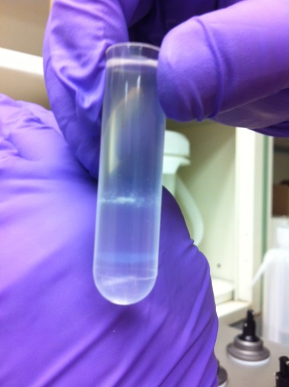
Figure 1: CsCl bands

- Withdraw contents of the band until the band is no longer visible (up to 1 mL) and dispense into a 1.5 mL microcentrifuge tube.

- In a beaker, prepare 2 L of phage dilution buffer to be used for dialysis.

- Using prepared dialysis tubing, cut a length that is sufficient for the volume of sample. Wear gloves.

- Rinse tubing with dH₂O, and attach a 50 mm closure to the bottom of the tubing.

- Add the sample (from day 3, step 6) to the dialysis tubing, and seal the top with a second closure with string attached to it (for retrieving the sample later).

- Submerge the sample/tubing in the buffer, and secure the sample to the beaker using the string and tape.

- Add a magnetic stir bar, and stir gently overnight at 4 °C.

Day Four

- Remove the tubing/sample from the buffer, open the top closure while holding the tubing, and pipette (or carefully pour) the sample into a screw-cap glass tube containing 200 μL of chloroform.

- Titer the phage. Store at 4 °C.

